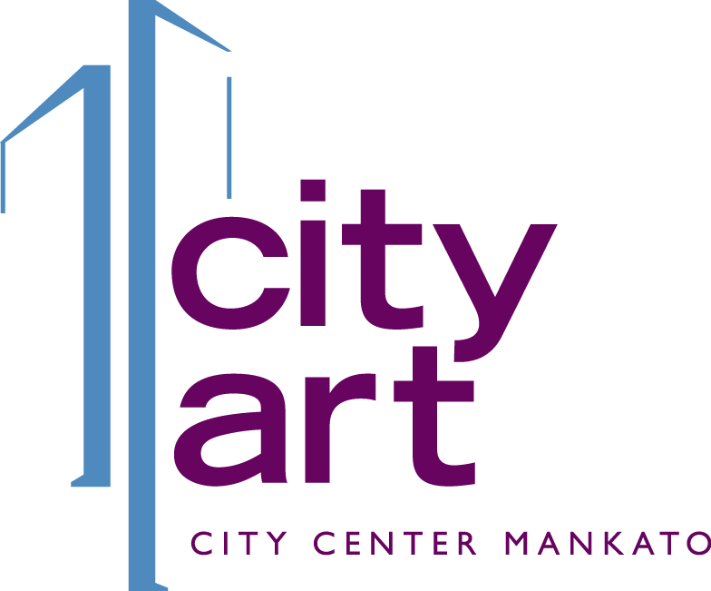

Credit Card Payment Form
Pay your CityArt Walking Sculpture Tour $25.00 entry fee by completing this form. Include with your submission materials or email directly to director@twinriversarts.org.
Business Name
_____________________________________________________________________________________
Contact Name
_____________________________________________________________________________________
Contact Email
_____________________________________________________________________________________
Contact Phone
_____________________________________________________________________________________
Name on Card
_____________________________________________________________________________________
Circle one: Visa MasterCard Discover American Express
Account Number Exp. Date
__________________________________________________ _____________________________
Security Code Billing Zip code
__________________________________________________ _____________________________
Payment Amount
__________________________________________________
Would you like a copy of the receipt emailed to the email address above? ____Yes ____ No
Authorization
I authorize Twin Rivers Council for the Arts to charge my credit card for the amount listed above.
Authorized Representative Name (printed): _________________________________________________
Authorized Signature: ___________________________________________________________________
Date: ______________________________________

