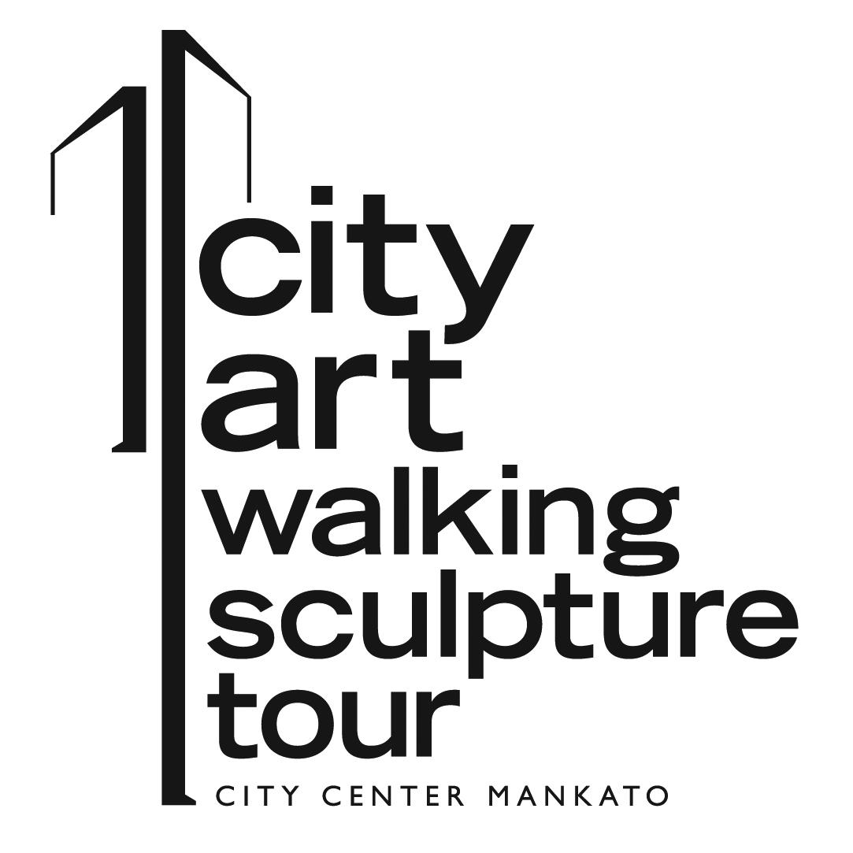

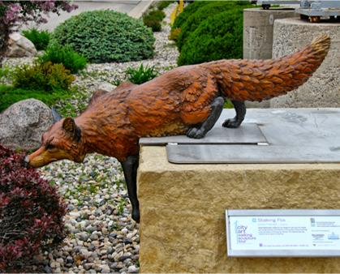
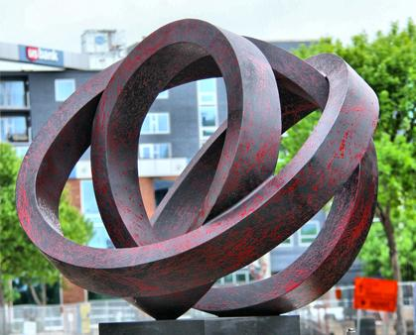
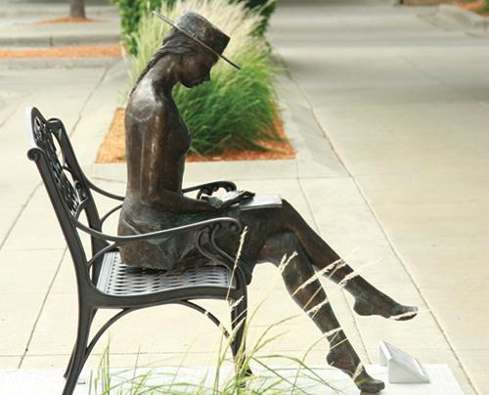

CityArt Walking Sculpture Tour 2017: May 12, 2018 – April 2019
Call for Artists
Entry Deadline: November 3, 2017

2018 CityArt Walking Sculpture Tour
The CityArt Walking Sculpture Tour is an exciting exhibition of outdoor sculpture displayed in the heart of downtown Mankato and North Mankato. Now in its eighth year, CityArt continues to draw thousands of visitors making the Greater Mankato arts community known around the region.

The sculpture tour is a collaborative program between Twin Rivers Council for the Arts (TRCA), Greater Mankato’s arts commission and the City Center Partnership (CCP), a downtown development organization representing Mankato and North Mankato. Both organizations are committed to creating a vibrant community through arts and culture programming.

Since its inception in 2011, CityArt has sold seventeen sculptures, purchased seven People’s Choice winning sculptures, and has facilitated several commissioned pieces as a result of the exposure artists receive from the program. CityArt is a member of the Partner Network sculpture exchange program based out of Sioux Falls, SD. For more information on the CityArt Walking Sculpture Tour, visit cityartmankato.com.

What Sets CityArt Apart
The CityArt Walking Sculpture Tour is coordinated by two full time staff from both TRCA and the CCP ensuring that there is a timely, clear flow of communication between the program and the artists. The staff works year-round promoting the sculpture walk and the artists to facilitate sales and make Greater Mankato an arts destination.

Teams of volunteers give of their time for take-down and installation making the process smooth and efficient. There is a strong partnership between the CityArt program and the cities of Mankato and North Mankato. Each city provides staff and needed equipment to assist our teams during take-down and install. As an artist, you can rest assured that your sculpture will be well managed and taken care of.

The CityArt installation weekend is full of fun, artistic events to make our artists feel welcomed by the community and appreciated for sharing their talents with us.

How It Works
The 2018 CityArt Walking Sculpture Tour will include 25 sculptures in the core blocks of Mankato and North Mankato, MN. CityArt obtains sculptures on loan from selected artists and provides each artist $1,000 per sculpture. The sculptures are displayed for about one year (May to April).

Artist Stipend
$1,000 per sculpture

People’s Choice Award
The People’s Choice sculpture (the sculpture with the most votes from the public) is purchased by the CityArt program (up to $18,000).

Awards
Best of Show Bronze - $1,000 Best of Show Other Material - $1,000

Shipping Reimbursement: Artists will receive up to $250 in shipping reimbursement if their sculpture is not sold and needs to be shipped back to them at the end of the tour. Anything over and above this amount is paid by the artist.

Accommodations: Two night stay at the Hilton Garden Inn during installation weekend in May which includes an artist reception on Friday night and an artist dinner on Saturday evening following installation.

Sculpture Selection
Entries will be critiqued on artistic merit, creativity, public safety, and durability in an outdoor setting. All artists will be notified of the selection committee decision by December 22, 2017. The selection committee consists of representatives from the CityArt Committee and art experts from the Greater Mankato community.

Artist Call for Entries
CityArt is open to professional and amateur artists of all backgrounds. Artists may submit up to three (3) of their own original sculptures (in concept, composition, and execution). The entry fee is $30.00. We welcome all sculptures and asking prices. Those not willing to accept CityArt’s People’s Choice purchase price (up to $18,000) for their sculpture can opt out of public voting.
Other Information
- All sculptures need to be in like-new condition when delivered to the CityArt program. We highly recommend that bronze be sealed and steel be repainted.
- The bases have a stainless steel plate that some sculptures are welded to. If your sculpture is made from a metal that is not compatible with stainless steel, you need to attach a steel plate or steel welding tabs to the bottom of your sculpture to ensure the weld will hold.
- CityArt provides liability and Inland Marine (collision and comprehensive) insurance coverage on all sculptures while on display.
- CityArt provides installation and volunteer support during installation weekend in May and during take down in April.
- CityArt receives 25% commission on sculptures sold and on any commissioned sculpture.
- If a selected artist declines to include his/her work in CityArt, an alternative artist will be selected.

Timeline
November 3, 2017 | Entry postmark deadline
December 22, 2017 | Notification of selection results
May 1, 2018  May 11, 2018 | Deadline for sculptures being shipped to Mankato  Mankato sculpture delivery & Artist Reception
May 12, 2018 | Installation & Artist Dinner
November 16, 2018 | People’s Choice Award announcement

For more information contact
Noelle Lawton, Executive Director
Twin Rivers Council for the Arts
507.387.2387 (office) / 708.703.7326 (cell)
director@twinriversarts.org
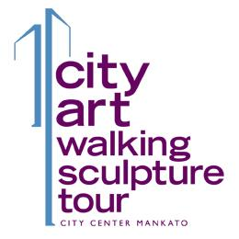

CityArt Walking Sculpture Tour 2018
Call for Artist Entry Form

SUBMIT ALL REQUESTED MATERIALS, ENTRY FEE AND ENTRY FORM BY NOVEMBER 3, 2017
Contact person for questions: Noelle Lawton, Executive Director, Twin Rivers Council for the Arts
507-387-2387 / director@twinriversarts.org

Print completed entry form and include $30.00 entry fee. Checks should be addressed to “Twin Rivers Council for the Arts – CityArt”. Mail completed form and entry fee to: Twin Rivers Council for the Arts, c/o Noelle Lawton, Executive Director, PO Box 293, Mankato, MN 56002. To pay by credit card, complete the attached “Credit Card Payment Form” and include with your application.

_____________________________________________________________________________________
Name Email

_____________________________________________________________________________________
Address

_____________________________________________________________________________________
Home phone Cell phone Website (if applicable)

2018 Sculpture Entries (No more than three entries can be submitted)
NAME OF SCULPTURE | MATERIAL | DIMENSIONS (H x W x D) | WEIGHT | PRICE
1

2

3

*I am willing to sell my sculpture for up to $18,000 if it wins the People’s Choice Award (check one):
Yes ___ No____ (You can maintain the public selling price and participate in the People’s Choice Award competition.)

Submit all required information via email to Noelle Lawton at director@twinriversarts.org or on a CD.
- Two high quality color photos or photos of scale model(s) - front and back of each sculpture entry (jpg format).
- At least two samples of previous sculptures (jpg format).
- Artist Statement explaining the sculpture(s) (pdf format).
- Artist biography and resume (pdf format).

